Oauth 2.0 – Process to generate bearer token
Client ID UAT:
37798069-30dd-48af-b548-08490c1b574e
Step 1: Generate JWT Token
- Go to https://jwt.io and select RS256 as algo

- Enter below to header section (Copy as is)
{
"alg": "RS256",
"typ": "JWT",
"kid": "Sl-SFdcxMan3ctHsBnnDGliz4Z5a4TbzEG0gWG3lhaka" static value to be pass, will be share by the Bank.
}

- Enter below into payload section (change jti to unique value, sub and iss is client id mentioned above, aud keep as is and exp is the expiry of the JWT token that will be generated)
{
"jti":"1623863273000", Any unique string
"sub":"37798069-30dd-48af-b548-08490c1b574e", client ID
"iss":"37798069-30dd-48af-b548-08490c1b574e", Client ID
"aud":"https://app.uat-opt.idfcfirstbank.com/platform/oauth/oauth2/token",
"exp":8054080528
}

- Copy the public and private key into the signature section
- Copy the jwt from left side panel
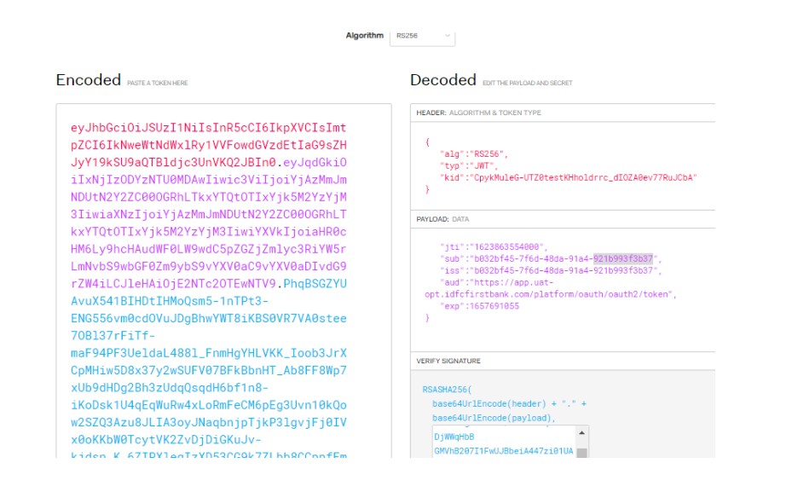
Step 2: Generate Bearer Token
- Use reqbin.com or Postman with below settings

- Method = POST and URL = https://apiext.uat.idfcfirstbank.com/authorization/oauth2/token
- Use below headers
Content-Type: application/x-www-form-urlencoded
Accept: application/json

- Copy below to content
grant_type=client_credentials static value
scope=generic-ovd-verify will be share by bank
client_id=37798069-30dd-48af-b548-08490c1b574e client id
client_assertion_type=urn:ietf:params:oauth:client-assertion-type:jwt-bearer static value
client_assertion=<<jwt token from step 1>>

- Click on Send. You will get the bearer token which can be used in API’s Authorization header
Available Scopes (multiple scopes can be mentioned separated by space in above request):
cms-mgmt-generateIssueReceiptMultiple
NOTE: multiple scope values can be passed with “space” separated
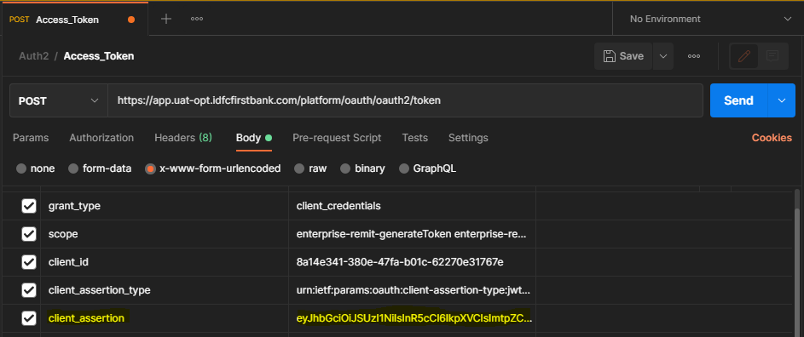
Postman Collection:

Sample Response:
Success: -
{
"access_token": "ABPUDTNShXGWXs_cJ6RhsAszRFUP2brR5LKc8WVAbaw.Hj5I68O-y6LqIg85bnL6MjdhlYNp5AUjIRimVIFxoyo",
"expires_in": 1799,
"scope": "paymenttxn-v1fundTransfer paymentenq-paymentTransactionStatus paymentenq-beneValidation cmsapibridge-common-enquireAccountBalance cmsapibridge-common-enquireAccountStatement",
"token_type": "bearer"
}

Failure: -
{
"error": "jti_known",
"error_description": "The jti was already used. Claim 'jti' from 'client_assertion' MUST only be used once."
}

Error list:
Error | Error Description | Comments
jti_known | The jti was already used. Claim 'jti' from 'client_assertion' MUST only be used once. | JTI should be unique for generating the Token.
invalid_request | The request is missing a required parameter, includes an invalid parameter value, includes a parameter more than once, or is otherwise malformed. Request parameter 'grant_type' is missing | ‘grant_type’ is missing in the header parameters
invalid_client | Client authentication failed (e.g., unknown client, no client authentication included, or unsupported authentication method). | ‘client_assertion_type’ is missing in the header parameters
invalid_request | The request is missing a required parameter, includes an invalid parameter value, includes a parameter more than once, or is otherwise malformed. The client_assertion request parameter must be set when using client_assertion_type of 'urn:ietf:params:oauth:client-assertion-type:jwt-bearer'. | client_assertion is missing in the header parameters

